2014 Past SAC Revision-Answers
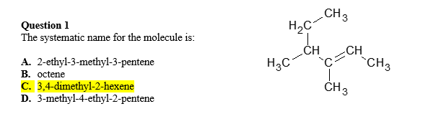
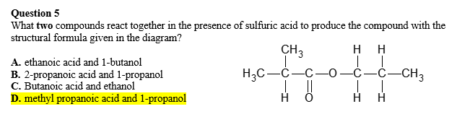
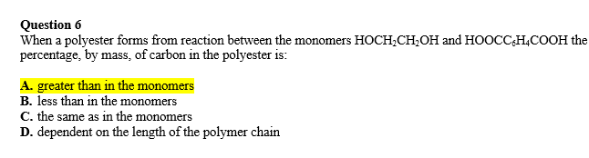
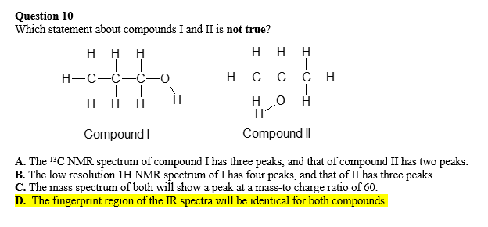
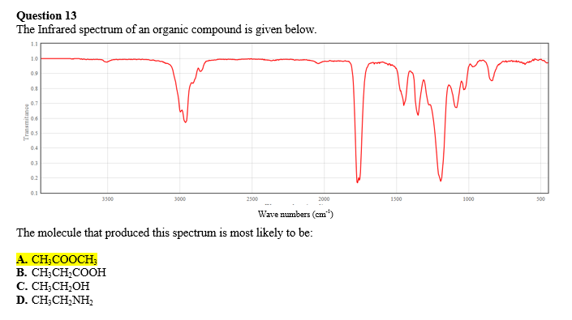

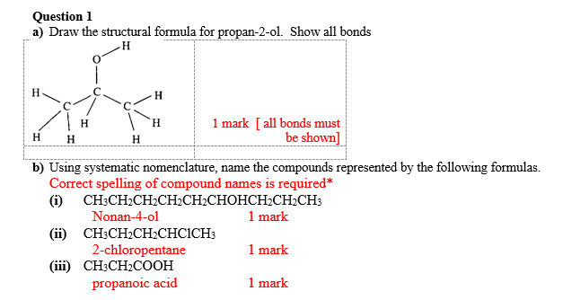
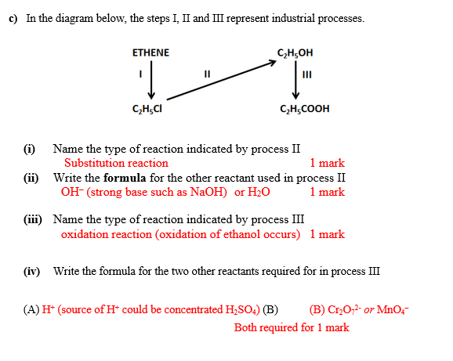

Question 2
The molecular formula of a compound, Z is C₃H₆Br₂
- The mass spectrum of compound Z is shown below.
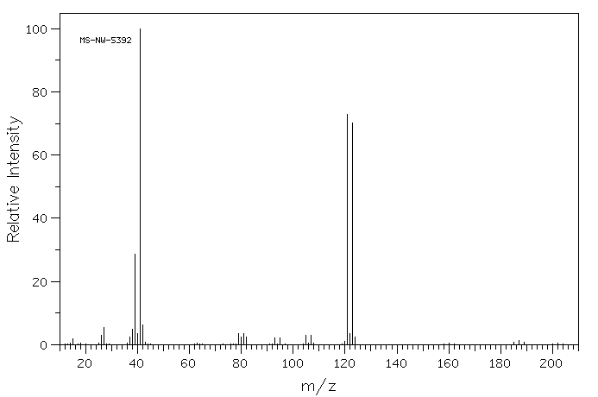
- The mass of the molecular ion is 200. Write an equation for the formation of this ion. No states are required.
C₃H₆Br₂ + e⁻ C₃H₆Br₂ + 2 e⁻ 1 mark

- What do the two peaks at m/z of 121 and 123 indicate about the relative abundance of ⁷⁹Br and ⁸¹Br? Give a reason for your answer.
- Relative abundance of ⁷⁹Br and ⁸¹Br are almost the same 1 mark
- The peak heights of the CH₃CH₂CH⁷⁹Br⁺ at m/z of 121 and CH₃CH₂CH⁸¹Br⁺ are similar 1 mark

- Identify the molecular mass of the most abundant ion.
- The molecular mass is 41 1 mark

- Compound Z has the following structure:

Write the systematic name of compound Z
- 2, 2 – dibromopropane 1 mark

- The NMR spectrum of compound Z is shown below.

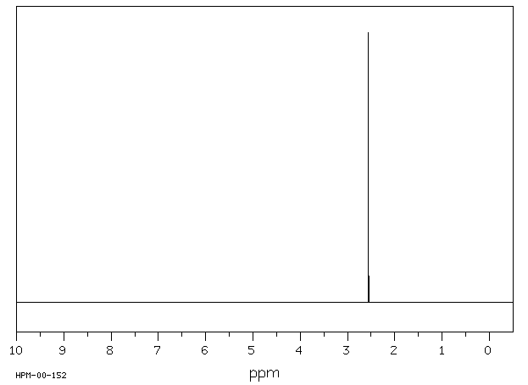 | 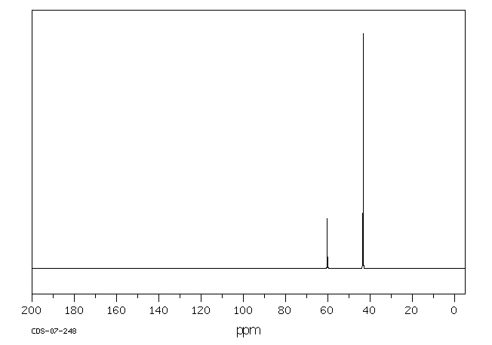
Spectrum B
Spectrum A
Which spectrum represents the ¹³C NMR of compound Z? Provide two valid explanations for your choice.

- Spectrum B AND one of the following
- The 2 different C environments produce two single peaks (as seen in spectrum B 1 mark
- There are 2 different Carbon environments of this compound; the first and last C atoms are in an identical environment because they attached to 3 hydrogen atoms each. The middle C atom is directly attached to two bromine atoms. 1 mark
- Spectrum A has a scale reference of 0 to 10 ppm which refers to a proton NMR spectrum
1 mark
- Compound Z has 6 protons in the same environment, and therefore you would see a singlet in spectrum A
1 mark

Total = 7 marks

Question 6
The structure of Compound X has the empirical formula of C₅H₁₀O_{2.} The mass spectrum, infrared spectrum and high resolution proton NMR spectrum for this compound are given below.

Mass Spectrum for Compound X
Mass spectrum
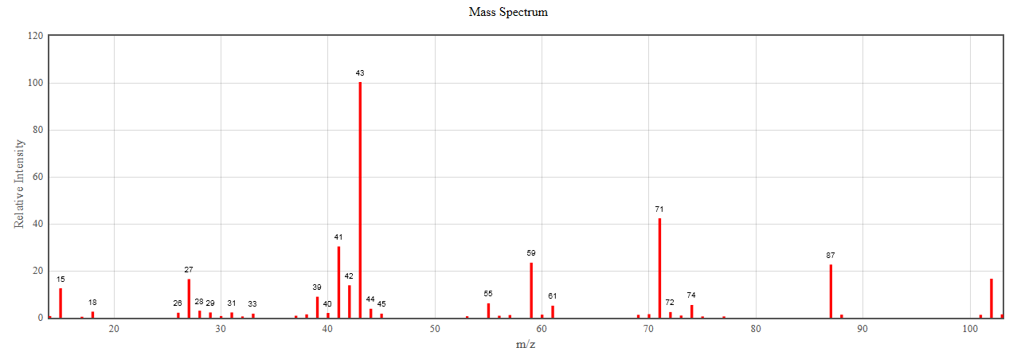
- (i) Give the formula of the component that produced the peak at mass/charge ratio 102.
C₅H₁₀O₂⁺ or [C₅H₁₀O₂]⁺ 1 mark

(ii) Account for the differences in structure for the components that produced the peaks at mass/charge ratio 102 and 103.
- The peak corresponding to mass/charge ratio 102 is caused by the molecular ion consisting of the ¹²C isotope. The Peak at 75 is caused by the molecular ion consisting of one ¹³C atom or ²H
1 mark

(iii) Would an isomer of Compound X produce the same or different spectrum to that given above? Give a reason for your answer.
Different 1 mark
- However, due to different structural arrangements, different fragments will be obtained.
1 mark
- Therefore, mass spectra of molecules will vary amongst isomers.

Infrared spectrum
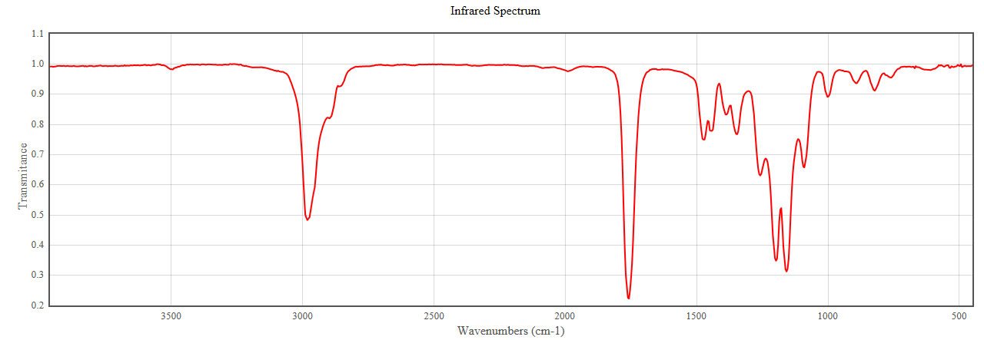
Wave numbers (cm⁻¹)
- (i) Use the infrared spectrum above to indicate the family of organic compounds to which compound X belongs. Give a reason to support your answer

- There is a strong absorption at 1700 cm⁻¹ due to the presence of C=O bond. There is no trough between 2500 to 3300 cm⁻¹ (due to -OH of an acid) 1 mark
- Compound X is an ester 1 mark

(ii) Would an isomer of Compound X produce the same or different spectrum to that given above? Give a reason for your answer.
- Isomers may have different functional groups and therefore different spectra will be produced.
1 mark
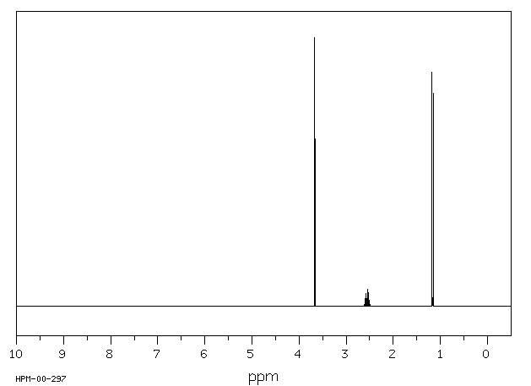
¹H NMR
Singlet; 3.7 ppm
Doublet; 1.2 ppm
Septet; 2.6 ppm

- Use the ¹H NMR spectrum above as well as the spectra from parts a) and b) to draw the structural formula of Compound X.

[1 mark was awarded to all students]

1 mark
Total = 9 marks

